Practical 15-16 :

Code :

class Wrap {

    public static void main(String[] args) {

       String s =args[0];

       Integer i = Integer.parseInt(s);

       System.out.println("i.byteValue()     : "+i.byteValue());

       System.out.println("i.doubleValue()   : "+i.doubleValue());

       System.out.println("i.floatValue()    : "+i.floatValue());

       System.out.println("i.intValue()      : "+i.intValue());

       System.out.println("i.shortValue()    : "+i.shortValue());

       System.out.println("i.longValue()     : "+i.longValue());

    }

}

Output :

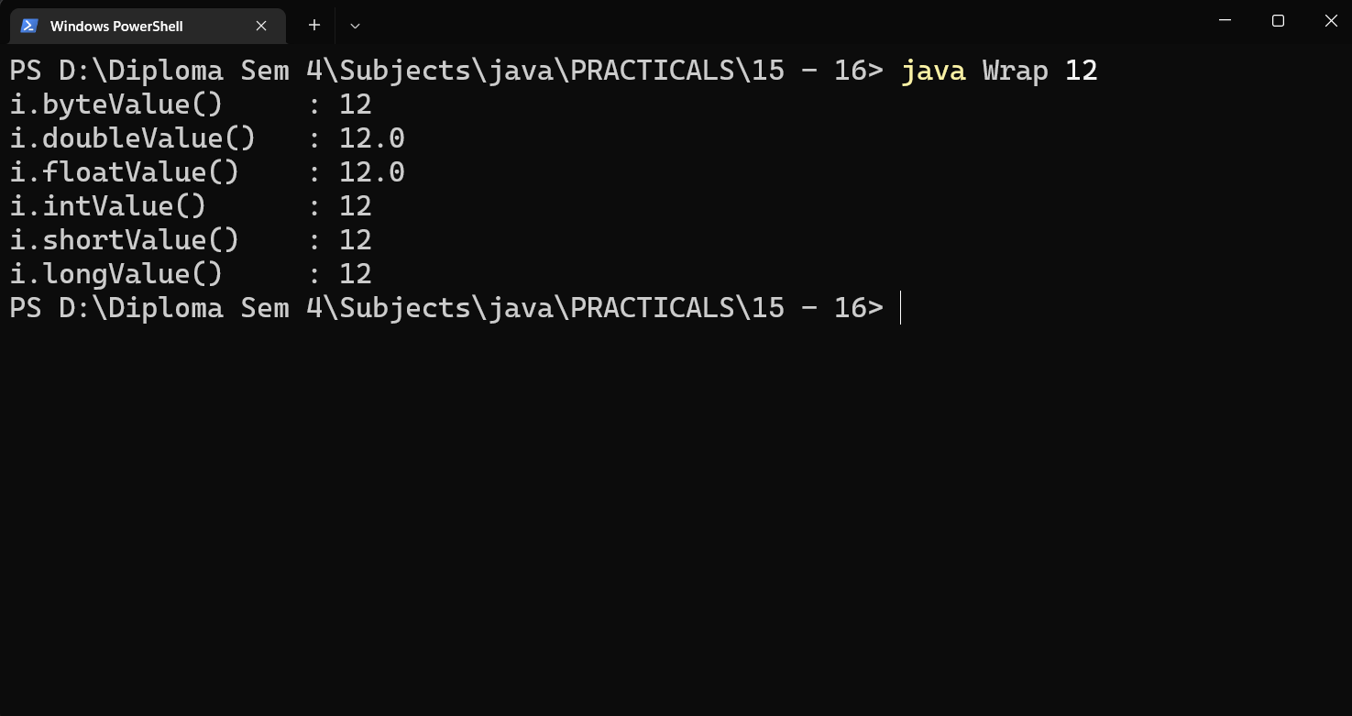

Code :

public class StrCon {

    public static void main(String[] args) {

        String  s = args[0];

        System.out.println("The String Vlue is : "+s);

        Integer i = Integer.parseInt(s);

        System.out.println("Converted Integer value is :"+i);

    }

}

Output :

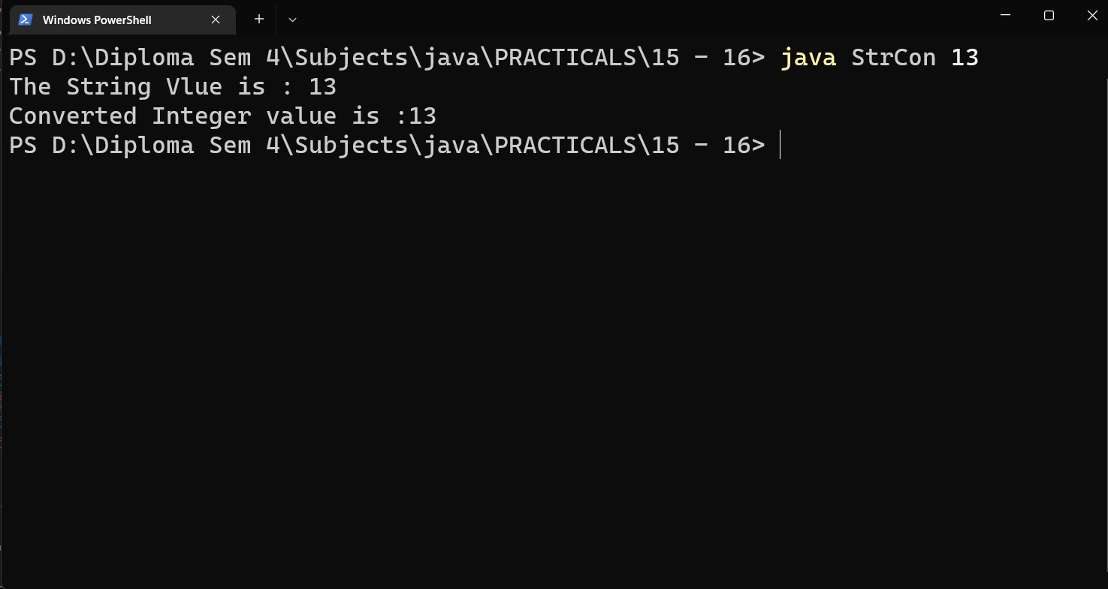

Code :

public class CharWrap {

    public static void main(String[] args) {

        char c1,c2;

        c1 = '1';

        c2='a';

        System.out.println(c1+" is Digit is "+Character.isDigit(c1));

        System.out.println(c2+" is Digit is "+Character.isDigit(c2));

        System.out.println(c1+" is Lette is "+Character.isLetter(c1));

        System.out.println(c2+" is Letter is "+Character.isLetter(c2));

        System.out.println(c1+" is Lower Case is "+Character.isLowerCase(c1));

        System.out.println(c2+" is Lower Case is "+Character.isLowerCase(c2));

    }

}

Output :

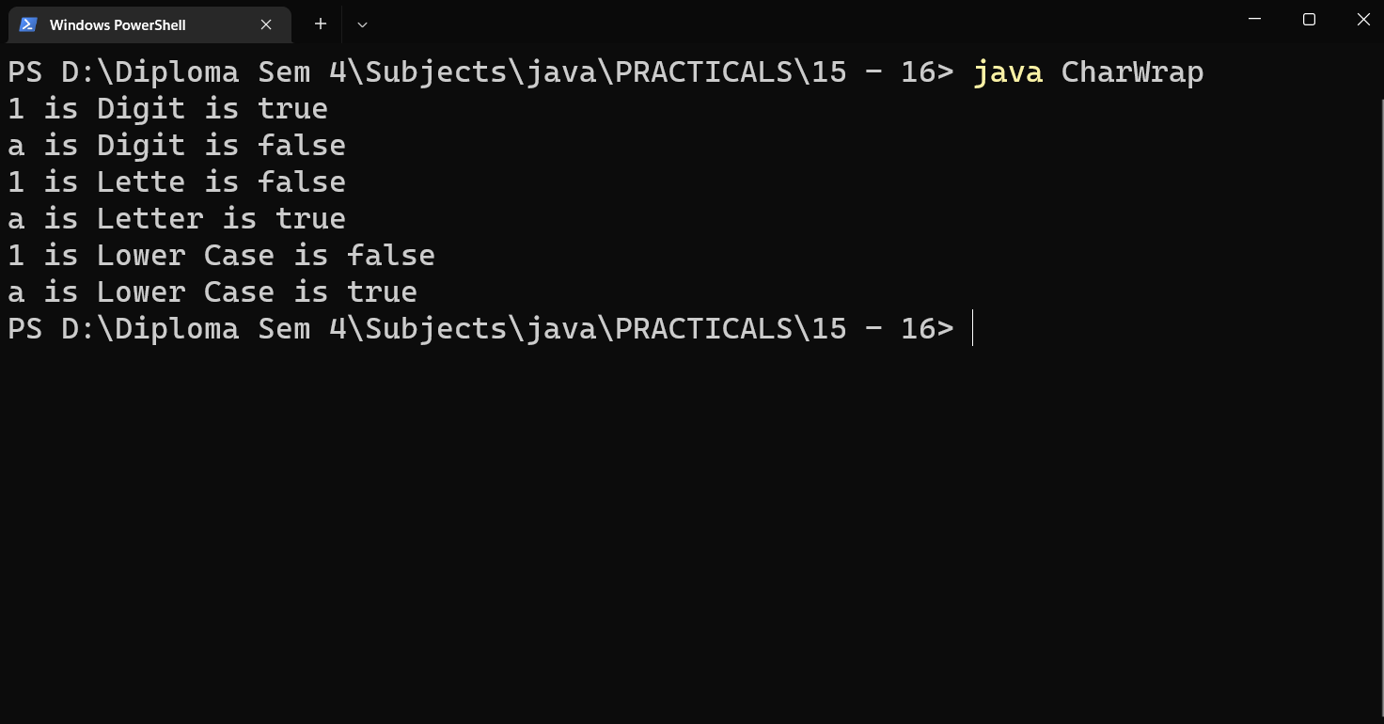

Code :

public class Primi {

    public static void main(String[] args) {

        Integer  i = 12;

        System.out.println("i.byteValue()     : "+i.byteValue());

        System.out.println("i.doubleValue()   : "+i.doubleValue());

        System.out.println("i.floatValue()    : "+i.floatValue());

        System.out.println("i.intValue()      : "+i.intValue());

        System.out.println("i.shortValue()    : "+i.shortValue());

        System.out.println("i.longValue()     : "+i.longValue());

    }

}

Output :

